Statement 1:
To get a required image quality from a drone camera it has to be at a optimum height..
But height plays an important role in covering the distance (for example small height covers only small area in a plane but if a drone is in higher height than it will cover more area).

So try to build a relation( if possible implement as an algorithm) between the height of the drone and covering area

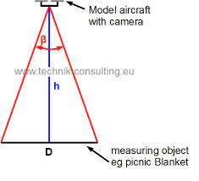

Statement 2:
What are autotuning methods in PID controller how to implement
Write a detail document or algorithm
Example :
Ziegler Nichols PID tuning method

Statement 3:
What are the factors affect by drone in real-world how to rectify it
Write a detail document

